AI assignment4:

Task 1:
Zero-shot: Prompt AI to write a function that checks whether a given year is a leapyear.

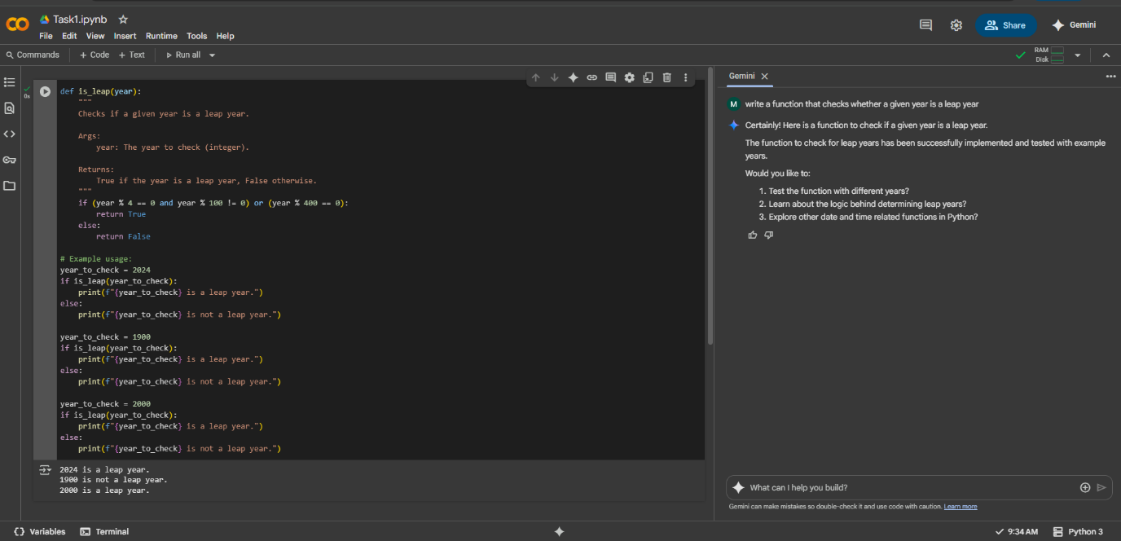
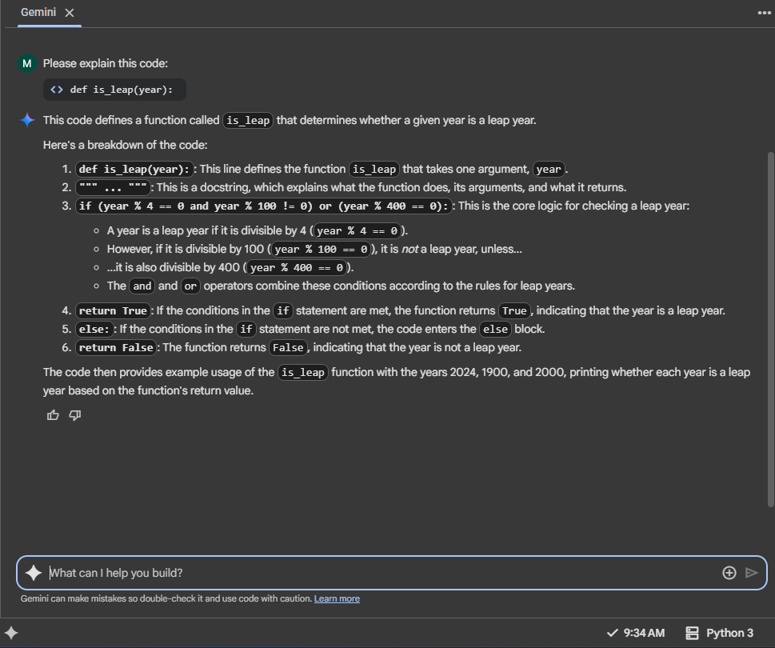

Task 2:
One-shot: Give one input-output example to guide AI in writing a function that converts centimeters to inches.
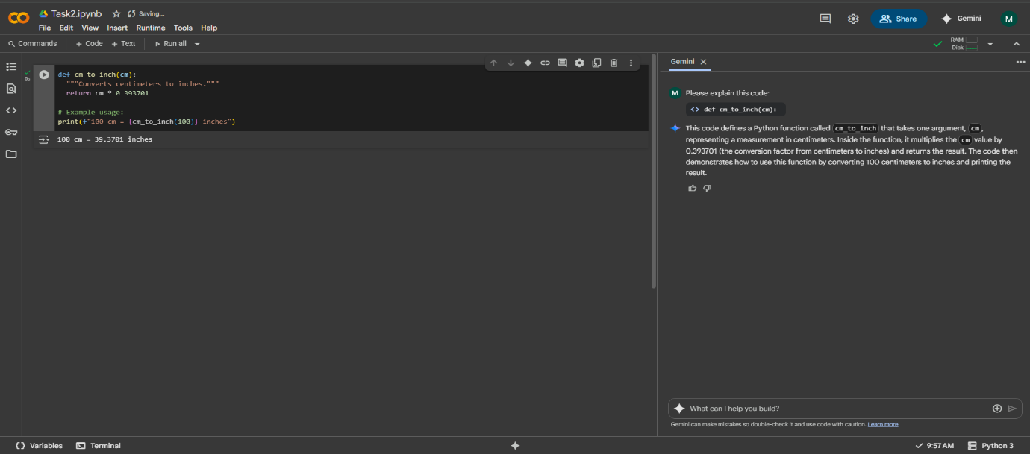
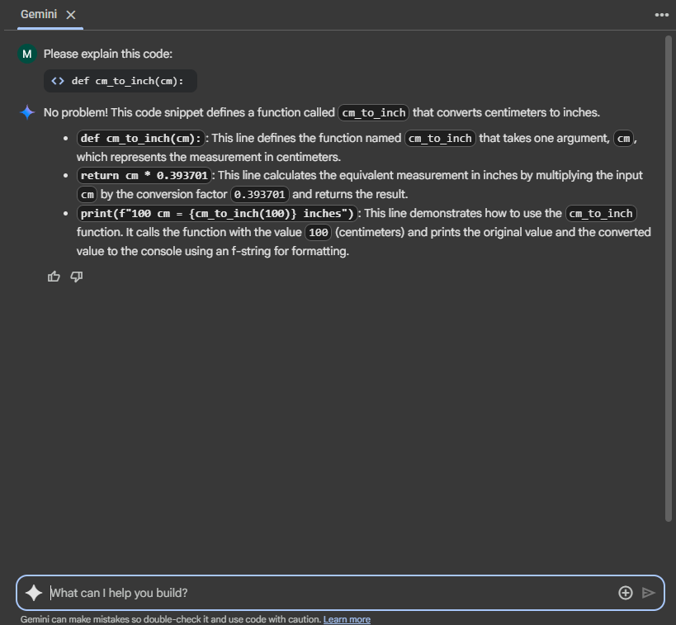

Task :3
Few-shot: Provide 2–3 examples to generate a function that formats full names as “Last, First”
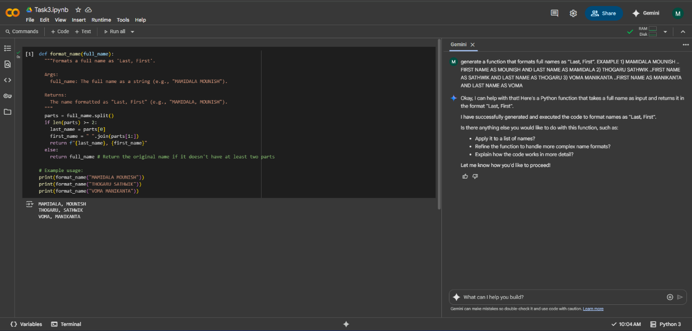
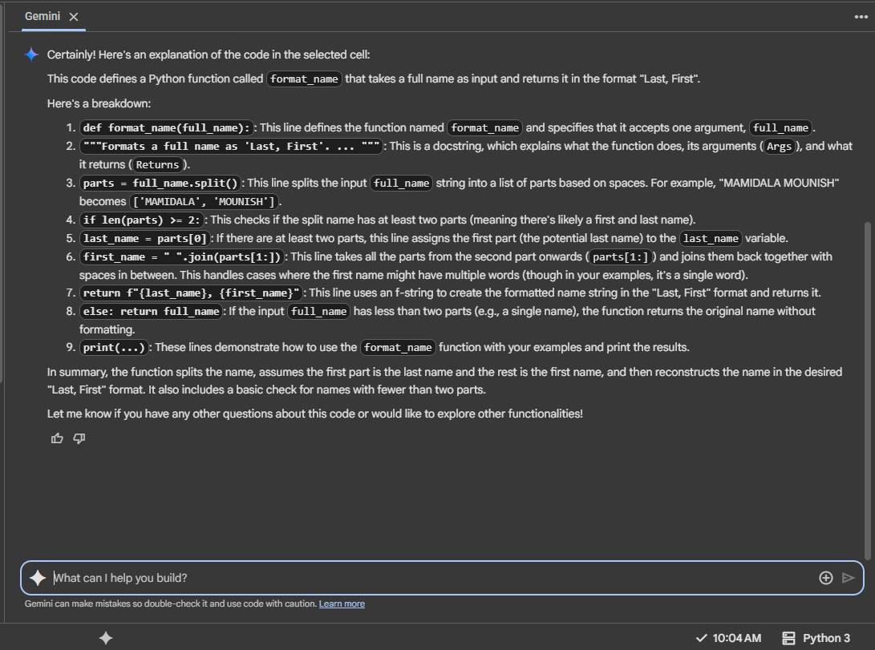

Task Description#4
Compare zero-shot and few-shot prompts for writing a function that counts the number of vowels in a string.
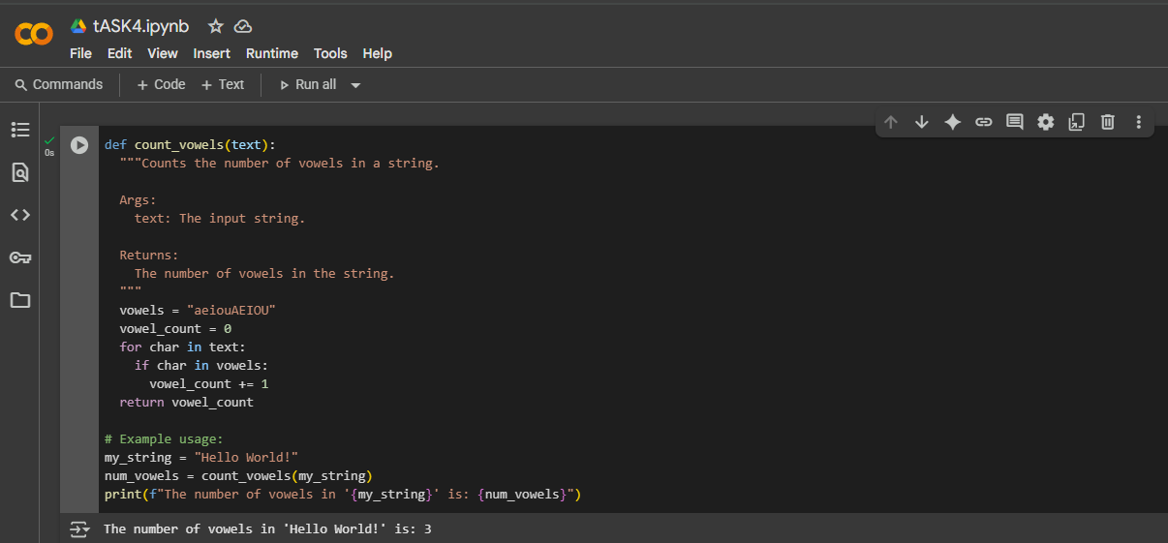
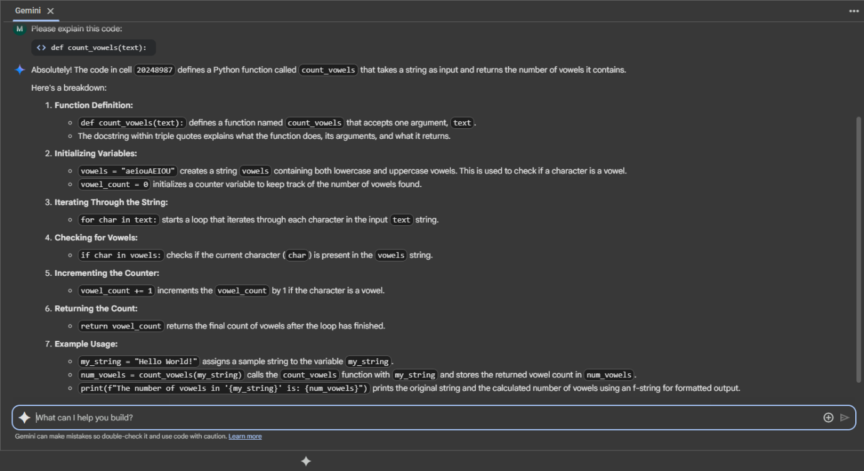

Task Description#5
Use few-shot prompting to generate a function that reads a .txt file and returns the number of lines
